|  |
| --- |
|  |
| SOVY |
| Digital Calculator PO1_DGC_HSI |

# Table of Contents

1. Document Status ……………………………………………………………………...2
2. Document History ……………………………………………………………………...2
3. Reference Documents ……………………………………………………………….....2
4. Project Description ……………………………………………………………………..3
5. System Context Diagram ……………………………………………….…………….....3
6. System Requirements …………………………………………………………………....4
7. Hardware Features………………………………………………………………………..6

# Document Status

|  |  |
| --- | --- |
| Name | SOVY |
| Version | 1.3 |
| Status | Proposed |
| Author | HM |
| Date | 22/2/2021 |

# Document History

|  |  |  |  |
| --- | --- | --- | --- |
| Version | Author | Date | Change |
| 1.0 | NK, NM | 13/2/2021 | Initial Creation |
| 1.1 | NK, NM | 14/2/2021 | Updating the system context diagram |
| 1.2 | HM | 19/2/2021 | Updating the requirements ID’s and making them atomic.  Added: - Lcd Features section  Deleted :  - Remove the Lcd From requirement sections |
| 1.3 | NM | 20/2/2021 | Updating the requirements ID’s and making them atomic.  Added: - Lcd datasheet in the reference document  - Req_1ST123_HSI_overall_006-V1.0  - Req_1ST123_HSI_overall_007-V1.0  - ­ Req_1ST123_HSI_overall_008-V1.0  - Req_1ST123_HSI_overall_009-V1.0  ­ - Req_1ST123_HSI_overall_010-V1.0  Edited:  - Project’s description  - Req_1ST123_HSI_overall_001-V1.1  - Req_1ST123_HSI_overall_002-V1.1  - Req_1ST123_HSI_overall_003-V1.1  - Req_1ST123_HSI_overall_004-V1.1  - Req_1ST123_HSI_overall_005-V1.1  Deleted  - Req_1ST123_HSI_overall_002-V1.0 |
| 1.4 | HM | 22/2/2021 | Deleted  -Lcd Features section from the table of content because it wasn’t deleted in 1.3 version. |

# Reference Documents

|  |  |  |  |
| --- | --- | --- | --- |
| **Ref. No.** | **Doc. Name** | **Version** | **Status** |
| 1 | PO1_DGC_CR_DigitalCalculator | 1.0 | Released |
| 2 | LCD_DataSheet | 1.0 | Released |

# Project Description

“Sovy” is a simple digital calculator in which the system consists of a keypad that holds all the buttons required to perform any basic mathematical operation and an LCD screen to display the operations performed. A beeping sound is generated from a buzzer whenever a key is pressed by the user.

# System Context Diagram

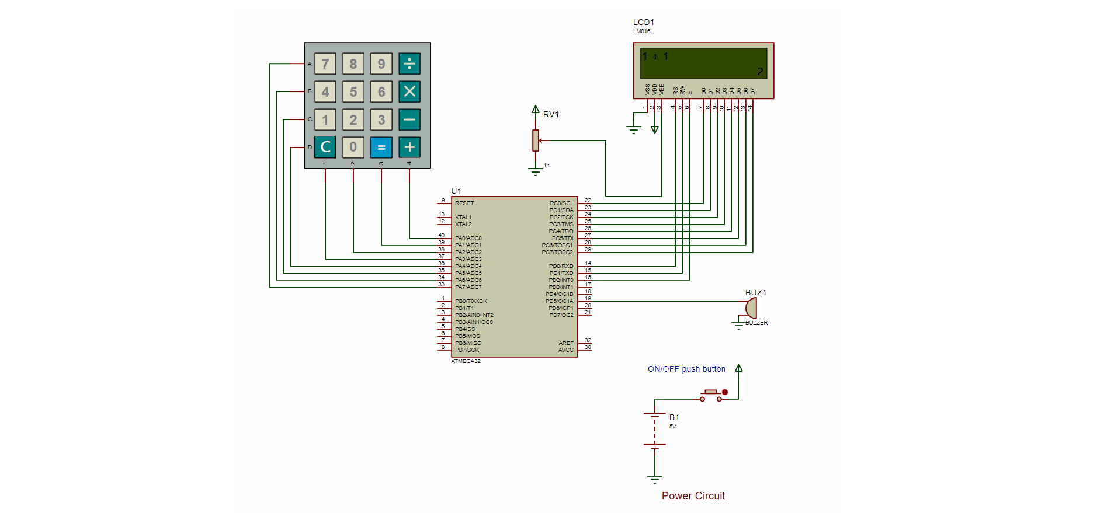

# System Requirements

|  |  |  |  |
| --- | --- | --- | --- |
| Req_ID | Req_1ST123_HSI_overall_001-V1.1 | Covers | Covers_1ST123_CR _01-V1.0 |
| Description: | * The Keypad(4x4) in total contains 16 keys, each of one is used to send a particular input to the microcontroller as required by the user:  1. 10 keys are used to represent the numbers from 0 to 9. 2. 4 keys are used to represent the 4 basic mathematical operations; addition, subtraction, multiplication & division. 3. 1 key is used to represent the equal button.  * Each row and column in the keypad has a separate pin which is connected to separate pin on the Atmega32 microcontroller. | | |

|  |  |  |  |
| --- | --- | --- | --- |
| Req_ID | Req_1ST123_HSI_overall_002-V1.1 | Covers | Covers_1ST123_CR_01-V1.0 |
| Description: | In addition to a power button is used to switch on/off the calculator, which controls the power circuit that is responsible for powering up the whole system, and hence switching the calculator on & off. | | |

|  |  |  |  |
| --- | --- | --- | --- |
| Req_ID | Req_1ST123_HSI_overall_003-V1.1 | Covers | Covers_1ST123_CR _02-V1.0 |
| Description: | * PINs 33, 34, 35, 36 of the MCU which are connected to the rows of the keypad are configured as output in which they are initially set high (5V) * PINs 37, 38, 39 ,40 of the MCU which are connected to the columns of the keypad are configured as input pull up. | | |

|  |  |  |  |
| --- | --- | --- | --- |
| Req_ID | Req_1ST123_HSI_overall_004-V1.1 | Covers | Covers_1ST123_CR_02-V1.0 |
| Description: | If a key got pressed, the column in which this key exists will send a signal of 0V to the microcontroller which indicates that a button (key) has been pressed. | | |

|  |  |  |  |
| --- | --- | --- | --- |
| Req_ID | Req_1ST123_HSI_overall_005-V1.1 | Covers | Covers_1ST123_CR _04-V1.0 |
| Description: | When any key in the keypad is released, an output of 5v (logic high) shall be generated by the MCU at PIN 19 where the buzzer is connected resulting in a beeping sound for 300ms. | | |

|  |  |  |  |
| --- | --- | --- | --- |
| Req_ID | Req_1ST123_HSI_overall_006-V1.0 | Covers | Covers_1ST123_CR _03-V1.0 |
| Description: | The LCD will be initialized, according to the initialization sequence mentioned in the LCD_DataSheet. | | |

# 

|  |  |  |  |
| --- | --- | --- | --- |
| Req_ID | Req_1ST123_HSI_overall_007-V1.0 | Covers | Covers_1ST123_CR_03-1.0 |
| 1.Vdd | The supply voltage of the LCD. 5V DC is supplied from the Microcontroller to this pin to turn on the LCD. | | |
| 2. Vss | The Ground Connection of the LCD. It is connected to the ground. | | |
| 3. Vo | The Contrast Control Pin. It is connected to a potentiometer in order to control the contrast for the display. | | |

|  |  |  |  |
| --- | --- | --- | --- |
| Req_ID | Req_1ST123_HSI_overall_008-V1.0 | Covers | Covers_1ST123_CR _03-V1.0 |
| 1. R/W pin | This pin is used to select between the Read and Write Option of the LCD. When this pin is made logic low, a write operation is performed and data is sent from the microcontroller to the LCD using the D0-D7 pins. When this pin is set high, a read operation is performed and data is sent from the LCD to the microcontroller using the D0-D7 pins on the LCD. | | |
| 2. Register Select pin | This pin is used to select whether to send data to display or perform some command on the LCD. When this pin is set high, a write operation will send data onto the data register for displaying on the LCD. When this pin is set low, a write operation will send some LCD specific command to be performed on the LCD. | | |
| 3. Enable Pin | This pin is used to enable the LCD. It is operated on the rising edge of a pulse. When data is fed onto the data lines and the R/W pin set, application of a short pulse will result in data being sent to the LCD. | | |

|  |  |  |  |
| --- | --- | --- | --- |
| Req_ID | Req_1ST123_HSI_overall_009-V1.0 | Covers | Covers_1ST123_CR _03-V1.0 |
| 1. Data pins | These 8 pins are used as a bus to send or receive data between the microcontroller and the LCD. | | |

|  |  |  |  |
| --- | --- | --- | --- |
| Req_ID | Req_1ST123_HSI_overall_010-V1.0 | Covers | Covers_1ST123_CR _03-V1.0 |
| 8. A(Led positive) pin | Connected to 5v. | | |
| 9.K(Led negative) pin | Connected to ground. | | |

# Hardware Features

|  |  |
| --- | --- |
| Hardware Component | Features |
| 1. Keypad | A **4x4 keypad** will have **eight terminals**. in them four are **rows of matrix** and four are **columns of matrix**. these 8 pins are driven out from 16 buttons present in the module. those 16 alphanumeric digits on the module surface are the 16 buttons arranged in matrix formation.   * Maximum voltage across each segment or button: 24v. * Maximum current through each segment or button: 30mA. * Maximum operating temperature: 0°c to + 50°c |
| 1. Microcontroller | ATmega32, low-power Microchip 8-bit AVR RISC-based microcontroller combines 32 KB ISP flash memory with read-while-write capabilities, 1 KB EEPROM, 2 KB SRAM, 54/69 general purpose I/O lines, 32 general purpose working registers, a JTAG interface for boundary-scan and on-chip debugging/programming, three flexible timer/counters with compare modes, internal and external interrupts, serial programmable USART, a universal serial interface (USI) with start condition detector, an 8-channel 10-bit A/D converter, programmable watchdog timer with internal oscillator, SPI serial port, and five software selectable power saving modes. The device operates between 1.8-5.5 volts. |
| 1. Buzzer | * Rated Voltage: 6V DC * Operating Voltage: 4-8V DC * Rated current: <30mA * Sound Type: Continuous Beep * Resonant Frequency: ~2300 Hz |